 | Sinhgad Technical Education Society’s  RMD Sinhgad School of Engineering, Warje, Pune.  Department of Electronics & Telecommunication Engineering.

Name of Student
Division
Roll Number
Experiment Title
Marks

 | Sinhgad Technical Education Society’s  RMD Sinhgad School of Engineering, Warje, Pune.  Department of E&TC Engineering | Expt. No.  1
Title | Hata Model for large city

Aim
Compute and compare the median loss by employing Hata model for various distance for carrier frequencies of 2.1 GHz and 6 GHz. Assume transmit and receive antenna heights of 40 m and 2 m in a large city. Plot the graph of path loss vs distance.

Apparatus
PC, Octave

Theory
To plan the installation and deployment of a wireless network, one needs to characterize the performance of the communication system in terms of the transmitted power and total load in terms of users that can be supported by the network. Link-budget of wireless link is a systematic listing of power losses and gains of different intermediate components in the transceiver chain.
Hata Model
The Hata model is a popular model for signal strength prediction proposed initially by the Japanese engineer Masaharu Hata in his 1980 paper titled “Empirical Formula for Propagation Loss in Land Mobile Radio Services”. The Hata model presents an analytical approximation for the graphical information based on another Okumura model. Parameters required for simulations:
$Hbts=$ Height measured from the base of the BTS tower to the radiation centreline
$Tbts =$ Terrain elevation at the location of the BTS
$Htav=$ Height of the average terrain (from 3 Km to 15 km distance from the BTS)
$Hm=$ Height of the mobile antenna in meters
$f=$ Range of frequencies in MHz
$d=$ Range of Tx-Rx separation distances in Kilometers
$Pt =$ Power transmitted by the BTS antenna in Watts
$Gt=$BTS antenna gain in dBi
$Hb= Hbts+ Tbts - Htav =$ Effective Height of the BTS antenna in meters
Models
Big City (Urban model)
$$aHm=3.2{\left(\log\left(11.75 Hm\right)\right)}^{2}-4.97; \\ C=0$$
Small & Medium City (Urban model)
$$aHm = (1.1\log{f}-0.7)Hm-(1.56\log{f}-0.8);$$
Sub-urban environment
$$aHm = \left(1.1\log{f}-0.7\right)Hm-\left(1.56\log{f}-0.8\right); \\ C=-2{\left(\log{\frac{f}{28}}\right)}^{2}-5.4;$$
Open Rural environment
$$aHm = \left(1.1\log{f}-0.7\right)Hm-\left(1.56\log{f}-0.8\right); \\ C=-4.78 {\left(\log{f}\right)}^{2}+18.33\log{f}-40.98;$$

$$A = 69.55 + 26.16\log{f} - 13.82\log{Hb}-aHm; \\ B = 44.9 - 6.55 \log{Hb}; \\ Path Loss \left(dB\right),PL=A+B\log{d}+C; \\ Received Signal Level\left(dB\right),Pr= 10\log{(Pt*1000)}+Gt-PL$$

 | Sinhgad Technical Education Society’s  RMD Sinhgad School of Engineering, Warje, Pune.  Department of E&TC Engineering | Expt. No.  1
Title | Hata Model for large city
 | Student Worksheet

Problem Statement
Compute and compare the median loss by employing Hata model for various distance for carrier frequencies of 2.1 GHz and 6 GHz. Assume transmit and receive antenna heights of 40 m and 2 m in a large city. Plot the graph of path loss vs distance.

Formulae
$Hbts=$ Height measured from the base of the BTS tower to the radiation centreline
$Tbts =$ Terrain elevation at the location of the BTS
$Htav=$ Height of the average terrain (from 3 Km to 15 km distance from the BTS)
$Hm=$ Height of the mobile antenna in meters
$f=$ Range of frequencies in MHz
$d=$ Range of Tx-Rx separation distances in Kilometers
$Pt =$ Power transmitted by the BTS antenna in Watts
$Gt=$BTS antenna gain in dBi
$Hb= Hbts+ Tbts - Htav =$ Effective Height of the BTS antenna in meters

Big City Model (Urban model)
$$aHm=3.2{\left(\log\left(11.75 Hm\right)\right)}^{2}-4.97; \\ C=0 \\ A = 69.55 + 26.16\log{f} - 13.82\log{Hb}-aHm; \\ B = 44.9 - 6.55 \log{Hb}; \\ Path Loss \left(dB\right), P_{L}=A+B\log{d}+C; \\ Received Signal Level\left(dB\right),P_{r} = 10\log{(Pt*1000)}+G_{t}-P_{L}$$

Conclusion
From the output result, it is apparent that the loss increases and the received power decrease with the increase in transmitter-receiver distance as well as the transmission frequency.

Review Questions
- Explain free space propagation model (Friis Propagation Model).
- Explain two-ray model.
- Employing the Hata model, compute the median loss at a distance d = 8 km, when the carrier frequency $fc = 2.1 GHz, hte = 40 m, hre = 2 m$ for a large city.
- What is meant by Small Scale Fading?
- Explain different types of diversity in wireless communications.

 | Sinhgad Technical Education Society’s  RMD Sinhgad School of Engineering, Warje, Pune.  Department of E&TC Engineering | Expt. No.  1
Title | Hata Model for large city
Name
Roll No.

Program
- clc;
- clear all;
- %----------Input Section---------------
- Hbts = 40; %Height measured from the base of the BTS tower to the radiation centerline
- Tbts = 350; %Terrain elevation at the location of the BTS
- Htav = 300; %Height of the average terrain (from 3 Km to 15 km distance from the BTS)
- Hm = 2; %Height of the mobile antenna in meters
- f = 2100; %100:100:3000; %Range of frequencies in MHz
- d = 0.5:0.5:15; %Range of Tx-Rx separation distances in Kilometers
- Pt = 0.020; %Power transmitted by the BTS antenna in Watts
- Gt = 10; %BTS antenna gain in dBi
- %--------------------------------------
- Hb = Hbts + Tbts - Htav; %Effective Height of the BTS antenna in meters
- C = 0;
- aHm = 3.2 * (log10(11.75 * Hm)) ^ 2 - 4.97;

- A = 69.55 + 26.16 * log10(f) - 13.82 * log10(Hb) - aHm;
- B = 44.9 - 6.55 * log10(Hb);
- PL = A + B * log10(d) + C;

- subplot(2, 1, 1)
- plot(d, PL, 'r', 'LineWidth', 2);
- title('Hata-Okumura Path Loss Model', 'Fontsize',20);
- xlabel('Distance - Kilometers', 'Fontsize',16);
- ylabel('Path Loss (dB)', 'Fontsize',16);
- %Compute Received Signal Level
- Pr = 10 * log10(Pt * 1000) + Gt - PL
- subplot(2, 1, 2)
- plot(d, Pr, 'r', 'LineWidth', 2);
- title('Hata-Okumura Model', 'Fontsize',20);
- xlabel('Distance - Kilometers', 'Fontsize',16);
- ylabel('Received Signal Level (dBm)', 'Fontsize',16);

Output

For $f=2100 MHz$
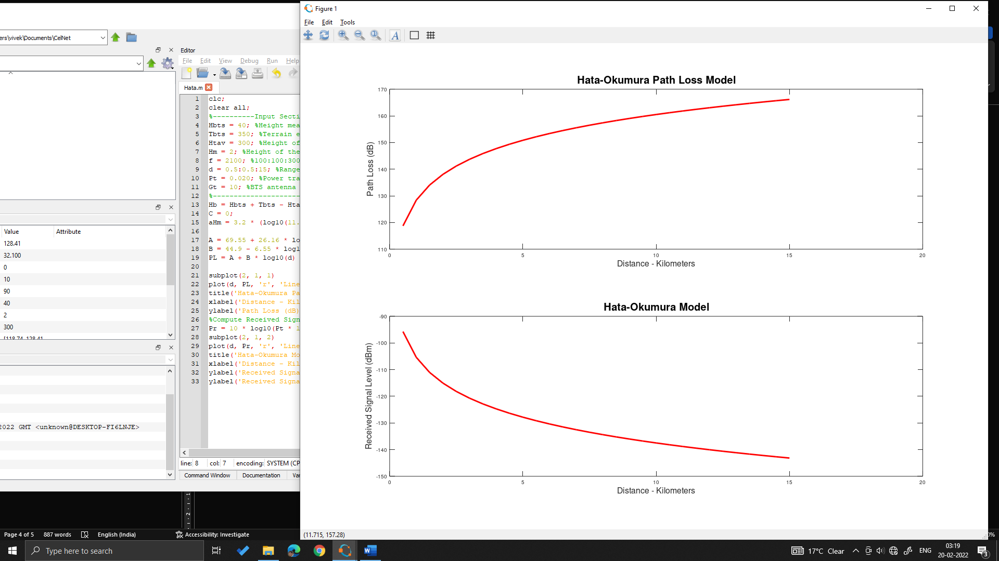

For $f=6000 MHz$
